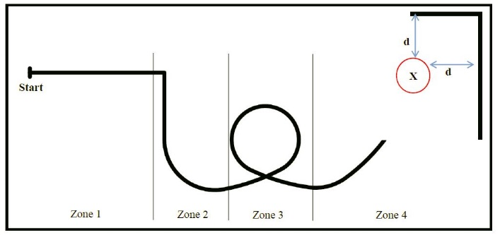

Race track

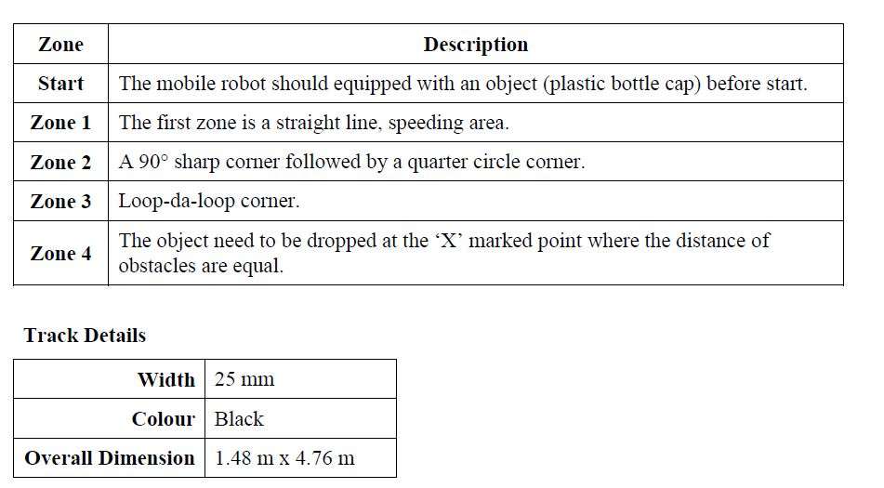

* The mobile robot will start at the starting point marked with **‘Start’ and a ‘T’ junction line**.
* It will start with **a line following mode** until the end of the track.
* At the end of the track, the mobile robot **need to drop a plastic bottle cap** that has been armed before it starts.
* It need to be **dropped at the ‘X’ marked point**. The point is guided with two obstacles and **located at 20 cm, d, from each obstacle**.
* During the race, the mobile robot must be **autonomous**.
* **Any manual interferences will be penalized and remotely controlled are strictly prohibited.**